Cricket Match Analysis using SQL

1. Executive Summary
The Cricket Match Analysis project was developed to analyze cricket match data using SQL and generate meaningful insights from historical match records. The project focuses on examining team performance, player achievements, venue statistics, toss decisions, and scoring patterns. By applying SQL queries on the cricket dataset, valuable business insights were extracted that help understand trends in match outcomes and team strategies.
The analysis demonstrates how SQL can be effectively used for data cleaning, data retrieval, aggregation, and business intelligence. This project showcases practical database management skills along with analytical thinking required for real-world data analysis.

2. Business Problem
Cricket generates a large amount of match-related data every season. Without proper analysis, it is difficult to identify performance trends, compare teams, evaluate player contributions, or understand how factors such as toss decisions and venues influence match results.
The primary business problem addressed in this project is to transform raw cricket match data into actionable insights using SQL queries. These insights can help coaches, analysts, and management make informed decisions based on historical performance.

3. Dataset Overview
The dataset contains historical cricket match records, with each row representing one completed match. It includes information related to teams, venues, scores, toss results, match winners, and player performances.

Main Attributes
Column | Description
Season | Tournament season
Home Team | Home team name
Away Team | Away team name
Toss Winner | Team winning the toss
Toss Decision | Bat or Field
First Innings Score | First innings total
Second Innings Score | Second innings total
Winner | Match winner
Player of the Match | Best player
Venue | Match venue
Start Date | Match date

4. SQL Concepts Used
The project applies several SQL concepts to retrieve and analyze the data efficiently.
- SELECT Statement
- WHERE Clause
- ORDER BY
- GROUP BY
- Aggregate Functions (COUNT, SUM, AVG, MAX, MIN)
- DISTINCT
- LIMIT
- CASE Statement (if used)
- Date Functions
- String Functions
- Data Cleaning
- Sorting and Filtering

5. Business Questions and Analysis
This section contains all SQL queries and their respective outputs.
Question 1
How many matches are available in the dataset?
SQL Query

Output
The dataset contains 1017 matches, providing a sufficient sample size for performance and trend analysis.

Question 2
How many matches were played in each season?
SQL Query
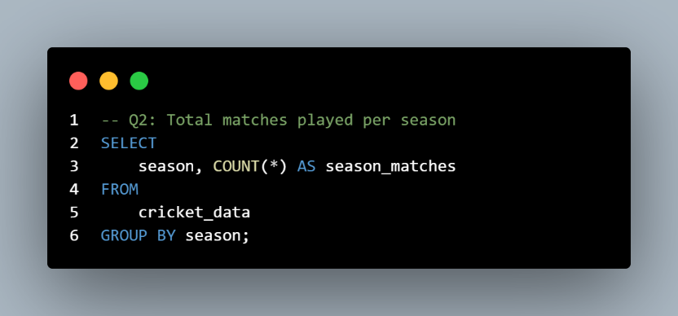

Output
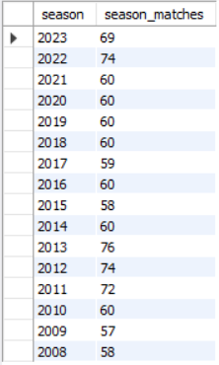

Question 3
Which team has won the highest number of matches?
SQL Query
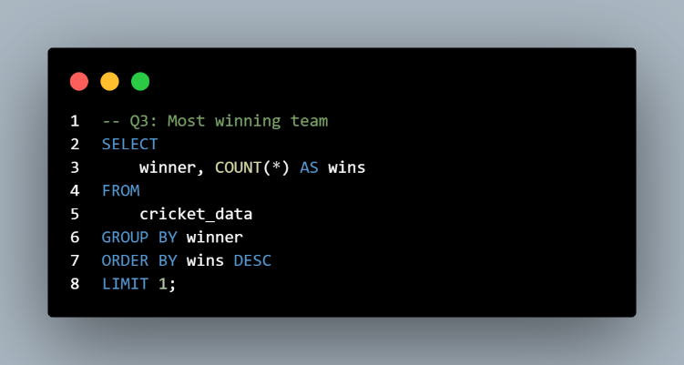
Output
MI emerged as the most successful team with 139 victories, demonstrating consistent performance throughout the tournament.

Question 4
Which are the top 5 most successful teams based on total match wins?
SQL Query
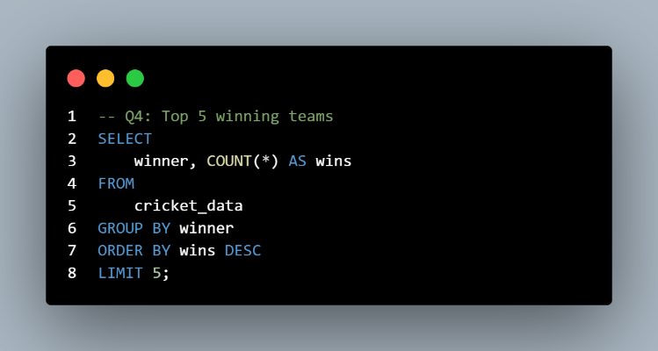
Output
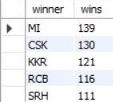

Question 5
How many matches were won by the team that also won the toss?
SQL Query
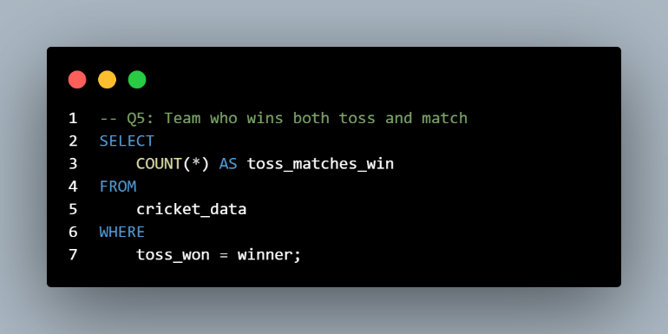
Output
Teams won both the toss and the match 521 times, suggesting that winning the toss provides a competitive advantage in many matches.

Question 6
What is the distribution of toss decisions (Batting vs Fielding) made by teams after winning the toss?
SQL Query
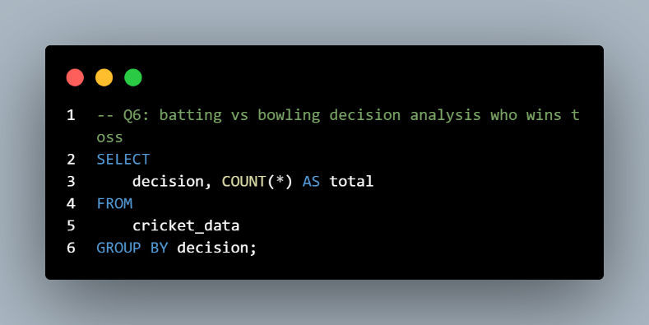
Output
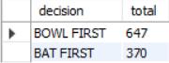

Question 7
What is the highest first innings score recorded in the dataset?
SQL Query
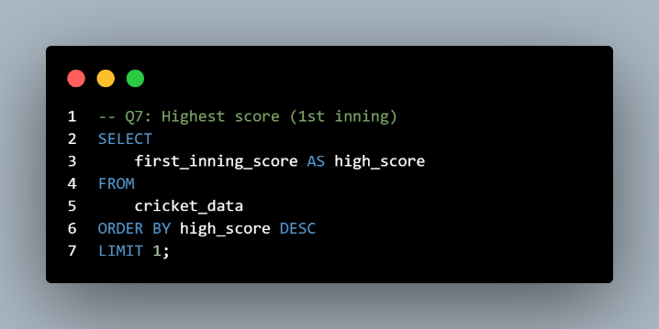
Output
The highest first-innings score of 263 reflects the batting potential under favorable pitch and weather conditions.

Question 8
What is the lowest first innings score recorded in the dataset?
SQL Query
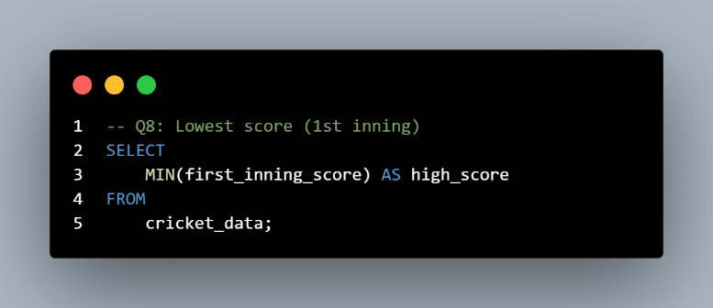
Output
The lowest first-innings score of 62 indicates exceptional bowling performances or challenging batting conditions.

Question 9
What is the highest successful run chase (second innings score) recorded in the dataset?
SQL Query
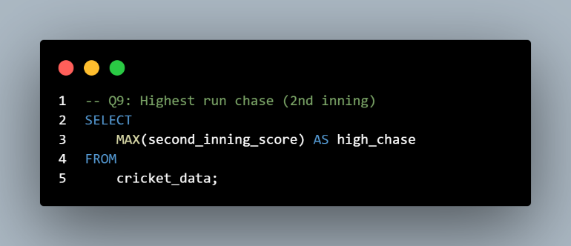
Output
A second-innings score of 226 represents one of the most successful run chases, showcasing the team's ability to perform under pressure.

Question 10
Which player has received the highest number of Player of the Match awards?
SQL Query
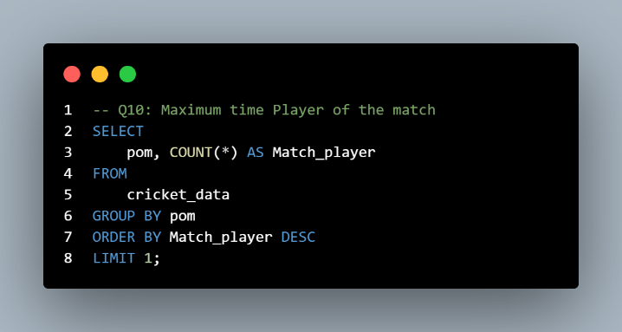
Output
AB de Villiers received the highest number of Player of the Match awards, highlighting outstanding individual contributions.

Question 11
Who are the top 5 players with the most Player of the Match awards?
SQL Query
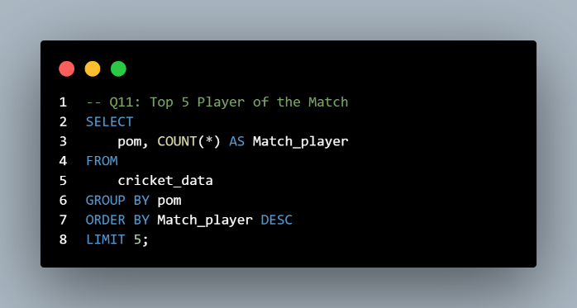
Output
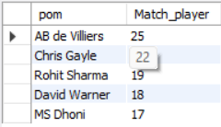

Question 12
How many matches has each team played as the home team?
SQL Query
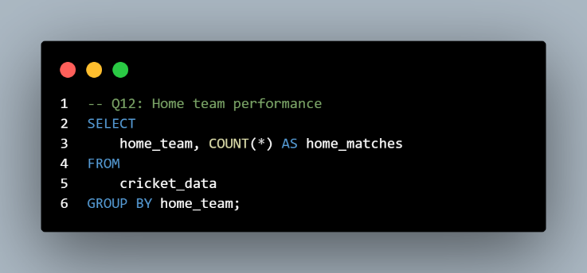
Output
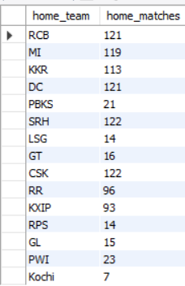

Question 13
How many matches has each team played as the away team?
SQL Query
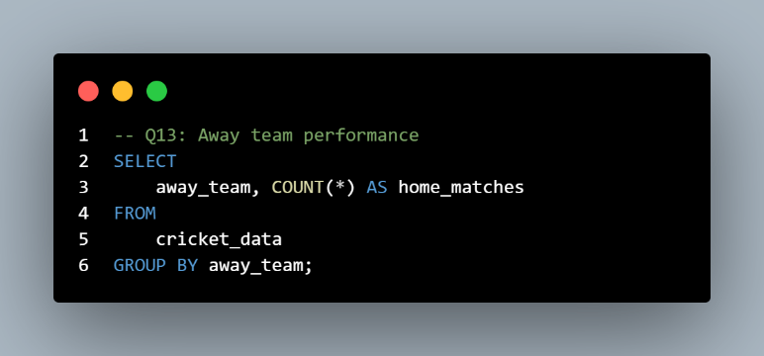

Output
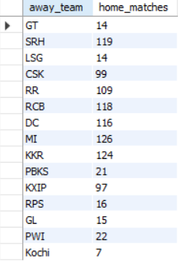

Question 14
Which venue has hosted the highest number of cricket matches?
SQL Query
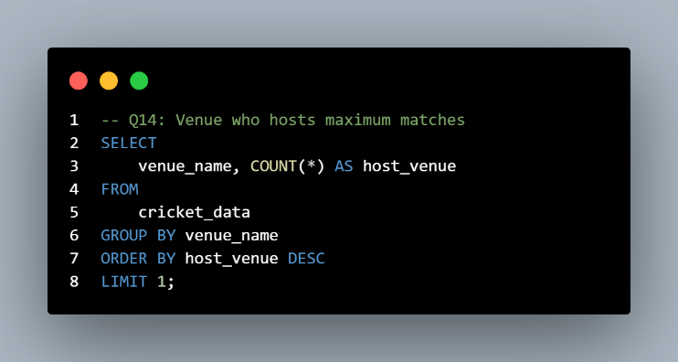
Output
Wankhede Stadium, Mumbai hosted the highest number of matches, making it one of the tournament's primary venues.

Question 15
How many matches were won while successfully chasing the target?
SQL Query
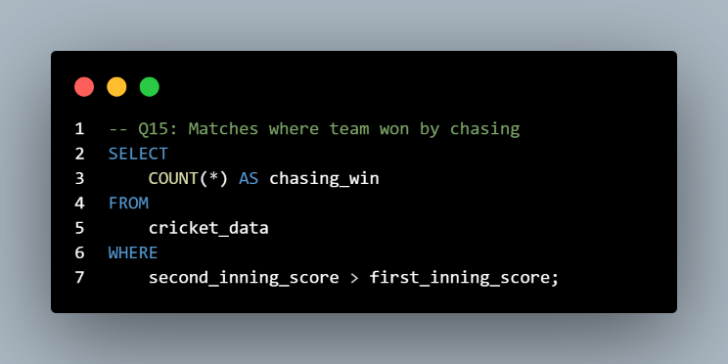
Output
535 matches were won while chasing, indicating that batting second was often a successful strategy.

Question 16
How many matches were won by successfully defending the first innings total?
SQL Query
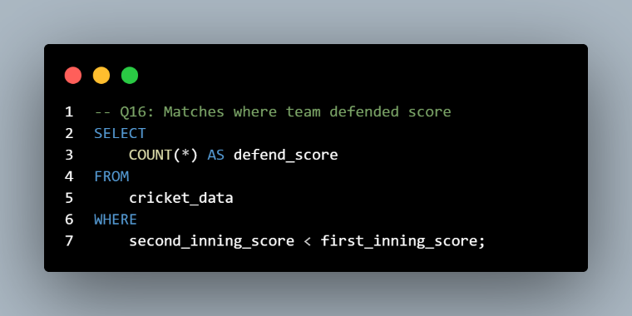
Output
468 matches were successfully defended, demonstrating that strong bowling attacks and disciplined fielding remain crucial for victory.

Question 17
What are the average first innings and second innings scores across all matches?
SQL Query
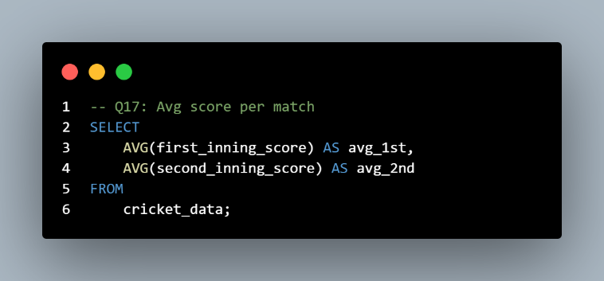
Output


Question 18
Which matches were closely contested, with a score difference of less than 10 runs?
SQL Query
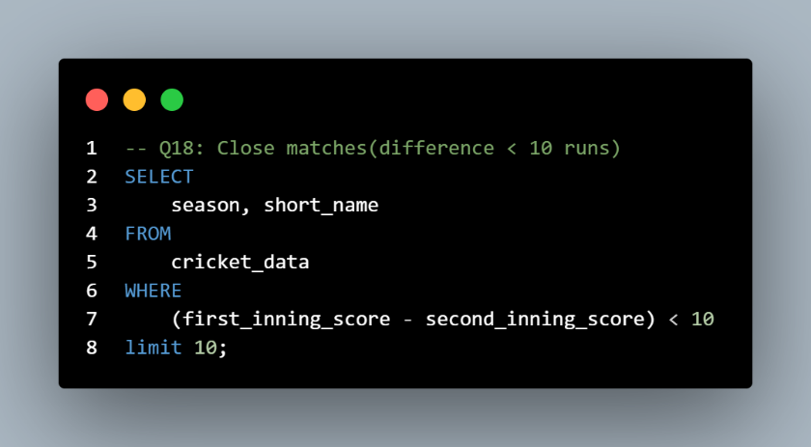
Output
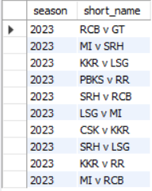
Question 19
What is the win percentage of each team based on the total number of matches in the dataset?
SQL Query
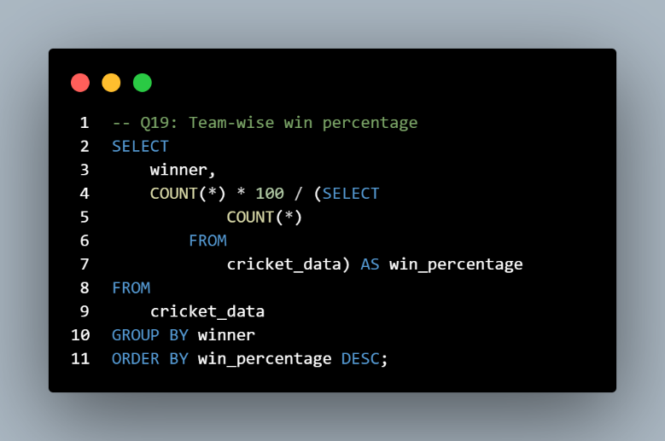
Output
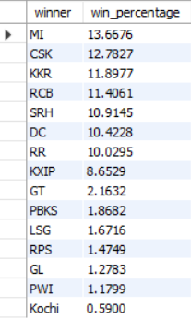

6. Key Insights
Based on the SQL analysis, the following key insights were identified:
- Certain teams consistently performed better across multiple seasons.
- Winning the toss increased the probability of winning the match in many cases.
- Teams preferred fielding after winning the toss more frequently than batting.
- Some venues hosted significantly more matches than others.
- A few players dominated the Player of the Match awards.
- Average first innings scores indicated the general scoring trend.
- Teams chasing targets won a considerable number of matches.
- Team performance varied across seasons.

7. Recommendations
Based on the analysis, the following recommendations can be made:
- Teams should analyze venue-specific performance before selecting playing strategies.
- Toss decisions should be based on historical venue statistics rather than fixed strategies.
- Consistent top-performing players should be retained as key members of the squad.
- Teams should prepare separate strategies for batting first and chasing targets.
- Performance trends should be reviewed every season to improve team planning.
- Historical data analysis can support better decision-making during tournaments.

8. Conclusion
This project successfully demonstrates how SQL can be used to perform business analysis on cricket match data. By applying SQL queries, meaningful insights were extracted regarding team performance, player achievements, venue statistics, and scoring trends.
The project highlights the importance of SQL in data analytics and business intelligence. It also strengthens practical knowledge of database management, query writing, data aggregation, and analytical problem-solving.
Future improvements may include integrating the database with Power BI or Tableau to create interactive dashboards and visual reports.

9. Skills Demonstrated
Throughout this project, the following technical and analytical skills were demonstrated:
Technical Skills
- SQL Query Writing
- Database Creation
- Data Import
- Data Cleaning
- Aggregate Functions
- GROUP BY Analysis
- Filtering and Sorting
- Business Data Analysis
Analytical Skills
- Problem Solving
- Data Interpretation
- Business Insight Generation
- Performance Analysis
- Decision Support
Tools Used
- MySQL
- VS Code / MySQL Workbench

